Name: | Period: | Date:
Date Started: | Due Date:
Group Members:
Advanced Design Applications
Learning Cycle 3: Manufacturing Unit 4

File 1.2 Looping Through Design Flashlight Design Brief
Looping Through Design Flashlight Design Brief
Background | Now that you have explored the principles of design as they relate to flashlight design, let’s consider the actual process involved with making a flashlight. Your instructor has selected a flashlight comprised of multiple components that require production and assembly. Given the product and your classroom as the manufacturing facility, you will be designing and implementing an assembly line using the five general design principles.
Design Problem | Create a facility for a flashlight manufacturing company.
What to Do: | To: Student Design Teams  From: Management  Re: Facility Design  Our company recently purchased a new building with the intention of dividing it into two major areas. One area would be dedicated to the actual production of the subcomponents and the second is reserved for the assembly of these components after they have been produced. We are giving your design team the challenge of creating a facility for our flashlight manufacturing company.  We, as a management team, have determined that we must address many factors before constructing the assembly portion of our facility. We hope to eventually automate the entire process, but we first must determine the general flow and order in which the subcomponents are assembled before investing the time and money into the equipment.  There are many companies in the world competing for the production of flashlights and, as management, we are very concerned about designing our facility to be as efficient as possible. Because of your experience with the basic design principles, your team has been hired to provide a solution to this problem. Specific details are provided below.  Thanks and good luck!  Management  Management  To: Student Design Teams  From: Management  Re: Facility Design  The design process can be used in a variety of ways to solve many different technological problems. Though this model is found in various forms, applying it helps to insure that a designer is taking into account the many different factors that influence design and the success of a final product.  You will be using this process to generate your solutions to the facility design. The five basic design principles should guide your research and influence your decisions about the proposed and implemented solutions. The following constraints and limitations must first be considered before solving this problem:  - The assembly line must consist of individual cells (or stations) through which the product must pass as it is being assembled.  - Since the cost of producing the line is expensive, each cell should consist of a person(s) rather than a machine to represent the automation.  - The research portion of the design process should take into consideration the five design principles, as they would apply to the facility design.  - At least two plausible solutions to the flashlight assembly problem must be proposed by the team before you are allowed to test your process design.  - The feedback stage of the cycle must include references to how each design principle could be improved within the facility design. These responses must be recorded.
Name: |  | Period: | Date:
Date Started: |  | Due Date:
Group Members:
Advanced Design Applications
Learning Cycle 3: Manufacturing Unit 4
File 1.2 Looping Through Design Flashlight Design Folio


- Define the Problem
Develop a problem statement that identifies the what, who, when and how the problem should be addressed.

- Brainstorming
List/sketch possible ideas for a factory design that might be used in your final design. Clearly identify and describe how each of these ideas relates to the problem statement.
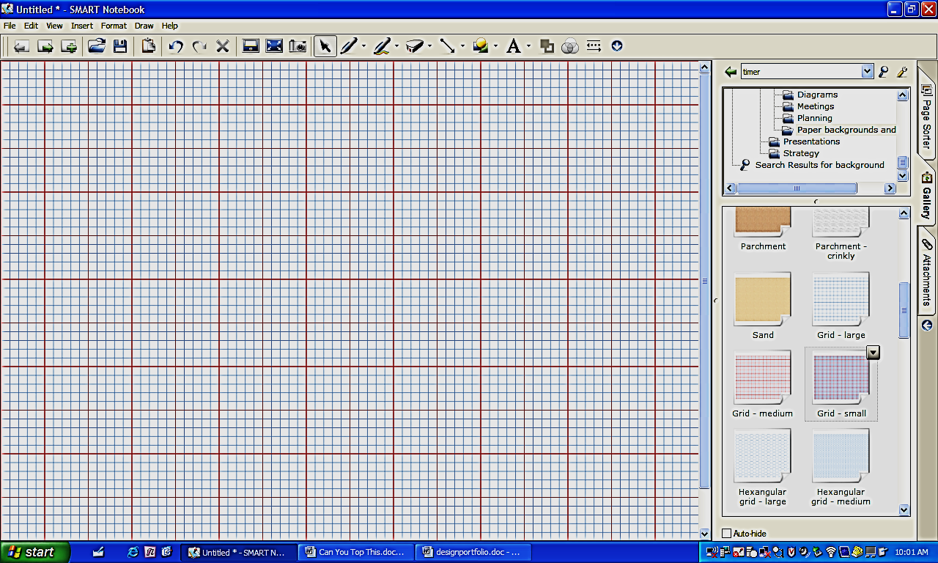

- Research and generating ideas
In the space below, document your research. Be sure to include proper citations at the end of your notes.

Market Research
“Design thinking” linked to the flashlight assembly project starts by formulating and answering some key questions:

- Who makes up the potential target market for the assembly?

- What are some of the key functional, emotional, and psychological needs of the target market?

- Has a budget been established for the project?

- What is your schedule for completion?

- What inspires you about this project?

- Identifying criteria and specifying constraints
What are the criteria and constraints of the design problem?
Review the letter from Management about what they need in the plant.

List the specific criteria and constraints for your Flashlight Assembly
Criteria | Constraints

- Exploring possibilities
Reflect on your brainstormed ideas and research notes and describe the plusses and minuses of each design approach you have considered. Is there an alternative solution you did not consider?

Brainstorming Idea | Pluses | Minuses
Idea 1
Idea 2
Idea 3
Idea 4
Idea 5

Did alternative solutions arise as you initially evaluated your designs? Cite examples.

- Selecting an approach
  - Enter the constraints and criteria of the project in the first column.
  - Score your brainstorming ideas against each constraint or criterion and indicate how well the idea meets the criteria and constraints.
3 pts = easily meets, 2 pts = somewhat meets, 1 pt. = does not meet
  - Total the columns and circle the highest score to indicate your best design idea.

3 pts = easily meets, 2 pts = somewhat meets, 1 pt = does not meet
Constraint/Criterion | Rate your  Brainstormed Ideas (3, 2, 1)
Constraint/Criterion | 1 | 2 | 3 | 4 | 5 | 6
Total

Justify the solution - Write a short paragraph justifying your solution. Include trade-offs that were made in the selection.

- Developing a design proposal
Take your highest-scoring brainstorming ideas and create working drawings (sketches with dimensions so that you could build your project) of your complete device. Attach your working drawings to this sheet.

Material to be Used | Qty

- Make Model/Prototype
Record the various tools, processes, and materials you will employee to achieve your solution.

Tools and Machines | Processes | Material

- Test and Evaluate
Compare actual results to desired results

What attributes of your flashlight assembly facility design solved the problem?
____________________________________________________________________________________________________________________________________________________________________________________________________________________________________________________________________________________________________________________________________

What attributes of your flashlight assembly facility design needed improvements? Describe possible changes you would make to a future model or prototype.
____________________________________________________________________________________________________________________________________________________________________________________________________________________________________________________________________________________________________________________________________

- Refine/Improve
Identify the problems you encountered with your solution and the modifications you used to overcome them. Then check the column to determine if your modifications made the design better.

Deficiencies of Design | Modifications | Better Results | Worse Results

- Create/Make Product
Attach a photograph of your finished project below. Describe your project in a way that would allow someone unfamiliar with the assignment to understand it.
________________________________________________________________________________________________________________________________________________________________________________________________________________________________________________________________________________________________________________________________________________________________________________________________________________________________________________________________

12. Communicate Results
What is the “Big Idea”? What understandings or concepts relate to math, science, and technology influenced the success of my project?
________________________________________________________________________________________________________________________________________________________________________________________________________________________________________________________________________________________________________________________________________________________________________________________________________________________________________________________________________________________________________________________________________________________________________________________________________________________________________________________________________________________________________________________________________________________________________________________________________________________________________________________________________________________________________________________________________________________________________________________________________________________________________________________________________________________________________________________________________________________________________________________________________________________________________________________________________________________________________________________________________________________________________________________________________________________________________________________

